Not Truly Separated on the Crossroads 9/17/2017
Matthew 18:21-35 Pr. H. Adachi
May the Grace and Peace of our Lord, Jesus, be poured into people’s hearts in the name of the Father and the Son and the Holy Spirit.
For the last couple of years, especially among my pastor friends and church member families, there are people who passed away much younger than the average age of life expectancy. For their spouses and close family members and friends, the situations are something like this: a crossroads suddenly appeared during their life’s journey and their loved ones are forced go right and they are forced to go left.
Usually when we encounter a crossroads in our lives, we may have choices to go right or left or continue going straight. However, when we encounter deaths, we have no choices. This past week, I read a newspaper article “Bereavement is the Highest Stress in One’s Life”.
Even though two people were walking together on the same road in life; now one person passes away and the other person who is left in this world are now heading in totally different directions after diverging at the crossroads. Then the person left in this world wonders if he or she could’ve done something or regrets something not done before they came to the crossroads. For example, if a husband could hold his wife before she would go right. In some cases, the surviving person will feel so alone and withdraw socially.
Six and half years ago, there was a big tsunami that hit the Tohoku area in Japan. There was a couple who thought that they would be okay if they stayed on the second floor of their home, despite the tsunami. However, they were not okay. When it came, the husband was holding his wife very tightly and they were together in the beginning.
However, while they were being flooded, he could not continue holding her. And they were separated from each other. Even though the husband survived, his wife’s body was found three months later. Since then, he carried a heavy burden. He is still feels that he cannot carry that burden. When one person loses loved one, spouse, partner, or significant other, the burden is tremendous and often feels unbearable.
In the parable given in today’s gospel that Jesus speaks about, there was the servant who could not pay back the loan to the lord. In the parable, the servant is us. The debt he could not pay back is many kinds of burdens that we carry in our lives, and the lord is God.
In our lives, we often encounter burdens that we do not think we can carry. Those burdens could be: anger towards someone who betrayed you, or something you cannot forgive yourself for because of mistakes, or your shame due to your actions in the past.
Those burdens are like huge debt that you cannot repay despite your best efforts. Who can forgive you? You might think nobody can. However, according to the text, the Lord, can wipe out the debt, in other words, God can unburden you. What we learn from what Jesus did on the cross is often called the “Theology of the Cross”. God, the Lord, Jesus Christ knows very well our burdens such as sins, failures, regrets, and shame…
He is very compassionate to us and understand our debt. He also suffers near us and with us. Therefore, he carried the cross and was crucified to pay our debt. In other words, he gives himself for us, human beings, to be freed from our failures, regrets, and shame. God loves each one of us and forgives us. Therefore, the only thing we need to do is love God and believe in God.
I would say further: The merciful God who suffers with us unconditionally loves us, regardless of our belief, God has already forgiven human beings and is pouring out his mercy and steadfast love to all. If we compare the relationship between God and human beings to a love affair, God has already loved us before each of us was born. Therefore, as long as you love God, there is no one-sided love.
Just one verse before today’s Gospel Text, there is a verse which reads, “For where two or three are gathered in my name, I am there among them.” This is a very important promise that Jesus makes to us. Today, of course he is together with us here in the sanctuary but he is also together in heaven with all people we are remembering today.
Well, some of you might think or wonder if your spouse or family members who passed away are not with Jesus since they were not Christians when they were living in this world. However, the Orthodox Church started from the beginning, has been using Icons that expresses God’s love that cannot be explained by words we write or speak. I think this Icon explained very well about the faith in Christ.
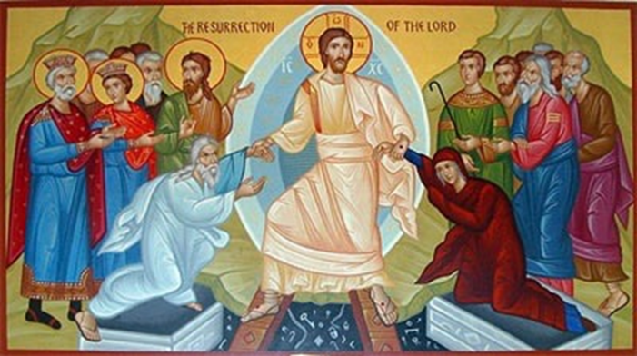For those of you, who have been worshipping at this Resurrection Lutheran Church, this Icon is getting familiar to you because this is the third time to show it. The person in the center, is Jesus Christ, who was crucified, died, buried, went to hell, but raised by God. When he is resurrecting extending his both hands, he is taking out Adam and Eve from their caskets.
According to the beginning of Genesis, the first Book of the Bible, Adam and Eve ate fruit from the tree that God told them not to eat. When Adam was asked by God “why did you eat?”, Adam replied “because Eve gave it to me.” Then Eve was asked by God, then she replied “Because the serpent deceived me.” Both gave excuses rather than confess their own sins. When Jesus resurrected, God saved and raised Adam and Eve from the dead. And they are together with Jesus in heaven. Of course, Adam and Eve were not Christians at that time.
I have maternal grandparents who were Buddhists. After my grandfather passed away at the age of 58, grandmother lived with us, a Christian Family, for her rest of her life. She brought a Buddhist altar with her to our house and she read Sutra every morning and evening in front of the Altar. To me, it seemed like she was speaking to grandfather by reading Sutra. When she died, my mother and uncle asked a Buddhist Temple to hold her funeral, even though my uncle and mother are Christians. My grandparents are resting in a Buddhist temple graveyard.
I believe wholeheartedly that God, the Son, and the Holy Spirit lovingly embraces my maternal grandparents and my paternal family members and stays with them in heaven.
In Christian worship services, not only in today’s Memorial Worship Service for All People, every week, heaven is disclosed to us. In our Apostle’s creed that we confess right after the message, we say “We believe the communion of Saints.” Even though we are separated from our loved ones on the Crossroads, we are together because of the love God shows us on the Cross now. Amen.

